EXP NO: 07 DESIGN OF FIR FILTER USING WINDOWING
DATE:28/08/2025 TECHNIQUE AND FREQUENCY SAMPLING METHOD

AIM:
To design the Low pass and high pass filters using windowing technique, using MATLAB software.
APPARATUS REQUIRED:
MATLAB Software.
THEORY:
FIR FILTER:
In signal processing, the FIR(Finite Impulse Response) is a filter whose impulse response is of finite duration because it settles to zero in finite time.
WINDOWING TECHNIQUE:
- HANNING WINDOW:
This is known as a cosine taper. Its starts at 0, rises to 1 in the middle of the period and then goes smoothly back down to 0 at the end.

w1(t)=0.5-0.5*cos(2pt/T)
If x(t) is the data (presumed to have zero mean value), then the windowed version of the data, y(t), is computed as follows:
Y1(t)=x(t)* w1(t)
- HAMMING WINDOW:
This modified cosine taper starts at 0.08, raises to to 1 in the middle of the period and then goes smoothly back down to 0.08 at the end.
w2(t)=0.54-0.46*cos(2pt/T)
y2(t)=x(t)* w2(t)

- BLACKMAN WINDOW:

This modified cosine taper uses two cosines.
W₃(t)=0.42-0.5*cos(2pt/T)+0.08* cos(4pt/T)
Y₃(t)=x(t)* w₃(t)

- KAISER WINDOW:
This tapering function has an adjustable parameter which can vary from 0 to ∞, but the range 3≤b≤10 is typical. When b=0, the Kaiser windows becomes a rectangular window(no tapering). As b rises, tapering increases and the main lobe width increases and sideband attenuation increases.

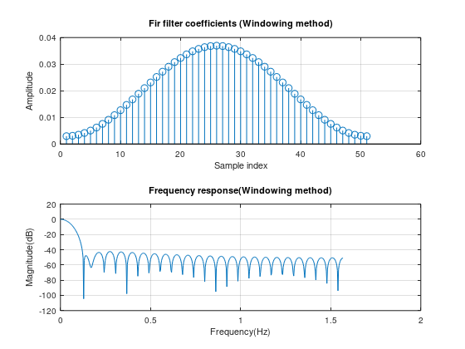
OUTPUT:

MAT LAB CODE FOR FIR FILTER USING WINDOWING TECHNIQUE:
N=51;
fc=0.25;
n=(0:(N-1))-(N-1)/2;
h_ideal=sin(2*pi*fc*n)./(pi*n);
h_ideal((N-1)/2+1)=2*fc;
window=hamming(N);
h_windowed=h_ideal.*window;
h_windowed=h_windowed/sum(h_windowed);
figure;
subplot(2,1,1);
stem(h_windowed);
title('Fir filter coefficients (Windowing method)');
xlabel('Sample index');
ylabel('Amplitude');
grid on;
[Hz,f]=freqz(h_windowed,1,512,'half');
subplot(2,1,2);
plot(f*0.5,20*log10(abs(Hz)));
title('Frequency response(Windowing method)');
xlabel('Frequency(Hz)');
ylabel('Magnitude(dB)');
grid on;

INFERENCE:

CONTENTS | MARKS AWAREDED | MARKS OBTAINED
PREPARATION | 40
OBSERVATION | 30
RECORD | 20
VIVA VOCE | 10
TOTAL | 100

RESULT:
Thus, the program for FIR filter using Windowing technique is performed and verified using MATLAB software.

EXP NO: 08 DESIGN OF IIR FILTER USING BILINEAR DATE:11/09/2025 TRANSFORMATION METHOD

AIM:
To design the low pass IIR filter using bilinear transformation method and to plot the magnitude response characteristics using MATLAB software.
APPARATUS REQUIRED:
MATLAB Software.
THEORY:
The bilinear transform (also known as Tustin's method) is used in digital signal processing and discrete-time control theory to transform continuous-time system representations to discrete-time and vice versa. The bilinear transform is a special case of a conformal mapping (namely, a Mobius transformation), often used to convert a transfer function of a linear, time-invariant (LTI) filter in the continuous-time domain (often called an analog filter) to a transfer function of a linear, shift-invariant filter in the discrete-time domain (often called a digital filter although there are analog filters constructed with switched capacitors that are discrete-time filters). It maps positions on the axis, , in the s-plane to the unit circle, , in the z-plane. Other bilinear transforms can be used to warp the frequency response of any discrete-time linear system (for example to approximate the non-linear frequency resolution of the human auditory system) and are implementable in the discrete domain by replacing a system's unit delays with first order all-pass filters.

OUTPUT:
Digital filter coefficients:
b =
1
a =
Columns 1 through 6:

1.0000e+00 -1.6087e+00 9.6398e-01 -2.5496e-01 -3.2608e-01 2.4941e-01

Columns 7 through 9:

-4.4653e-02 -1.7347e-18 9.9228e-03
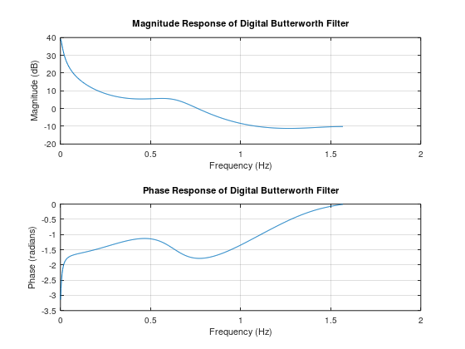

MAT LAB CODE FOR DESIGN OF IIR FILTER USING BILINEAR
TRANSFORMATION:
N = 4;
Wp = 0.2;
Fs = 1;
theta = (2*(1:N) + N - 1) * pi / (2 * N);
poles = exp(1j * theta);
poles = (2 * Fs + poles) ./ (2 * Fs - poles);
function [b, a] = compute_tf_coeffs(poles, k)
a = 1;
for i = 1:length(poles)
a = conv(a, [1 -real(poles(i)) -imag(poles(i))]);
end
b = k;
end
[bz, az] = compute_tf_coeffs(poles, 1);
disp('Digital filter coefficients:');
disp('b = ');
disp(bz);
disp('a = ');
disp(az);
[Hz, f] = freqz(bz, az, 512, 'half');
f = f * 0.5;
subplot(2,1,1);
plot(f, 20*log10(abs(Hz)));
title('Magnitude Response of Digital Butterworth Filter');
xlabel('Frequency (Hz)');
ylabel('Magnitude (dB)');
grid on;
subplot(2,1,2);
plot(f, angle(Hz));
title('Phase Response of Digital Butterworth Filter');
xlabel('Frequency (Hz)');
ylabel('Phase (radians)');
grid on;

INFERENCE:

CONTENTS | MARKS AWAREDED | MARKS OBTAINED
PREPARATION | 40
OBSERVATION | 30
RECORD | 20
VIVA VOCE | 10
TOTAL | 100

RESULT:
Thus, the IIR filter has been designed by using bilinear transformation technique and the output has been verified using MATLAB.

EXP NO: 09 DESIGN OF IIR FILTER USING IMPULSE DATE:18/09/2025 INVARIANT METHOD

AIM:
To design the low pass IIR filter using impulse invariant method and to plot the magnitude response characteristics using MATLAB software.
APPARATUS REQUIRED:
MATLAB Software.

THEORY:
Impulse response (IIR) is a property applying to any linear time invariant system. Common examples of linear time invariant systems are most electronic and digital filters. Systems with this property are known as IIR systems or IIR filters and are distinguished by having an impulse response which doesn’t becomes exactly zero past a certain point, but continuous indefinitely. This is contrast to FIR in which the impulse response h(t) thus becomes exactly zero at times t>T for some finite T, thus being of finite duration. The primary advantage of IIR filter over FIR filter is that typically meet a given set of specifications with a much lower filter order than a corresponding FIR filter.

OUTPUT :
Digital IIR Filter H(Z)=B(Z)/A(Z):
Numerator:B(z)=1
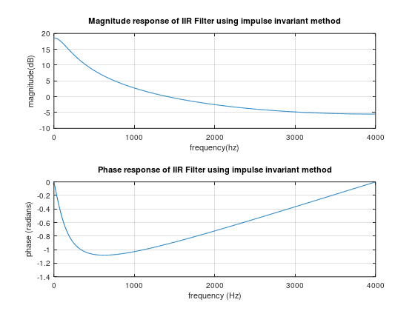
Denomenator:A(Z)=1-0.8825*Z{-1}

MAT LAB CODE FOR DESIGN OF IIR FILTER USING IMPULSE INVARIANT METHOD:
a=1000;
Fs=8000;
T=1/Fs;
alpha=exp(-a*T);
Bd=1;
Ad=[1,-alpha];
disp('Digital IIR Filter H(Z)=B(Z)/A(Z):');
disp(['Numerator:B(z)=',num2str(Bd)]);
disp(['Denomenator:A(Z)=1-',num2str(alpha),'*Z{-1}']);
N=512;
[H,w]=freqz(Bd,Ad,N,Fs);
subplot(2,1,1);
plot(w,20*log10(abs(H)));
xlabel('frequency(hz)');
ylabel('magnitude(dB)');
title('Magnitude response of IIR Filter using impulse invariant method');
grid on;
subplot(2,1,2);
plot(w, angle(H));
xlabel('frequency (Hz)');
ylabel('phase (radians)');
title('Phase response of IIR Filter using impulse invariant method');
grid on;

INFERENCE:

CONTENTS | MARKS AWAREDED | MARKS OBTAINED
PREPARATION | 40
OBSERVATION | 30
RECORD | 20
VIVA VOCE | 10
TOTAL | 100

RESULT:
Thus, the IIR filter has been designed by using Impulse invariant technique and the output has been verified using MATLAB.

EXP NO: 10 VERIFICATION OF BIBO STABILITY OF SYSTEM
DATE:25/09/2025

AIM:
To determine the BIBO (Bounded Input Bounded Output) stability of a discrete-time system by analyzing its poles using MATLAB software.
APPARATUS REQUIRED:
MATLAB Software.
THEORY:
BIBO stability is a concept in digital signal processing and control theory that ensures a system's output remains bounded for any bounded input. For a discrete-time system to be BIBO stable, all its poles must lie within the unit circle in the z-plane. This condition ensures that the system’s response does not grow unboundedly over time. By locating the system's poles and verifying they all lie within the unit circle, we can confirm the stability of the system.

OUTPUT:
Poles of the system:
0.9000
0.9000
Zeros of the system:
1
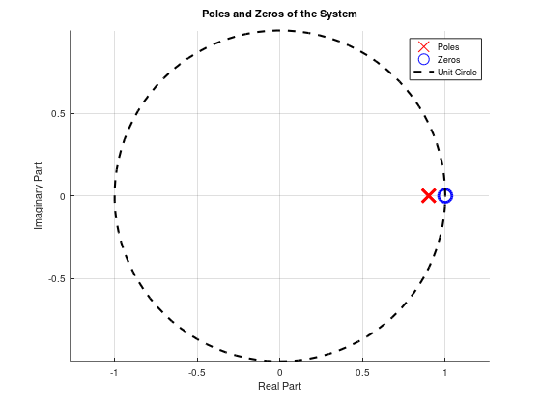
The system is BIBO stable.

MATLAB CODE FOR VERIFICATION OF BIBO STABILITY OF SYSTEM:
b = [0.5, -0.5];
a = [1, -1.8, 0.81];
poles = roots(a);
zeros = roots(b);
disp('Poles of the system:');
disp(poles);
disp('Zeros of the system:');
disp(zeros);
is_stable = all(abs(poles) < 1);
if is_stable
disp('The system is BIBO stable.');
else
disp('The system is NOT BIBO stable.');
end
figure;
hold on;
plot(real(poles), imag(poles), 'rx', 'MarkerSize', 10, 'LineWidth', 2);
plot(real(zeros), imag(zeros), 'bo', 'MarkerSize', 10, 'LineWidth', 2);
theta = linspace(0, 2*pi, 100);
x = cos(theta);
y = sin(theta);
plot(x, y, 'k--', 'LineWidth', 1.5);
title('Poles and Zeros of the System');
xlabel('Real Part');
ylabel('Imaginary Part');
axis equal;
grid on;
legend('Poles', 'Zeros', 'Unit Circle');hold off;

INFERENCE:

CONTENTS | MARKS AWAREDED | MARKS OBTAINED
PREPARATION | 40
OBSERVATION | 30
RECORD | 20
VIVA VOCE | 10
TOTAL | 100

RESULT:
Thus, the poles of the system have been analyzed, and it has been determined whether the system is BIBO stable based on their locations within the unit circle in the z-plane.

